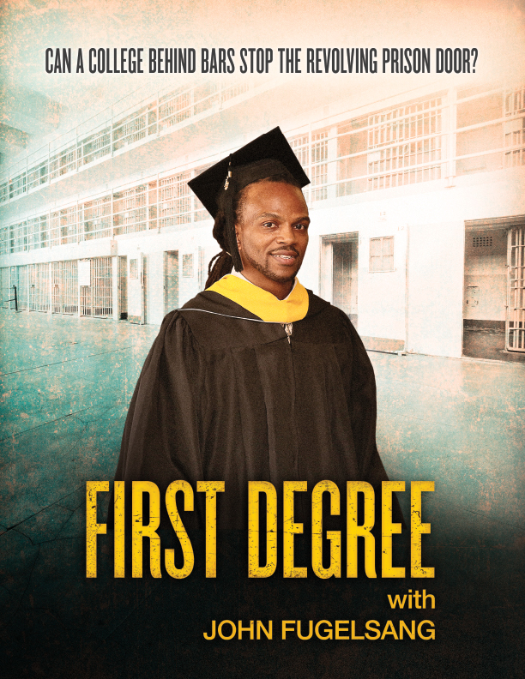

FIRST DEGREE puts a human face on a college behind bars that prevents
released inmates from returning to prison.

Please join us for a screening of this new documentary
at ___________________

Date___, Time___, Place____
Panel discussion with_________after screening

[Contact information to RSVP]
Thanks to the generous support of several foundations, we are able to offer this special screening at no cost.
For more information about the film, please go to http://www.pppdocs.com/firstdegree
https://www.facebook.com/pppdocFirstDegree/
https://twitter.com/firstdegreefilm

